# INTRODUCTION TO PROJECT

The web-based “Electronics E-commerce Platform” project aims to replicate the essential functionalities of an online electronics shopping platform. This system provides users with the ability to browse a wide range of electronic products, including laptops, smartphones, speakers, and headphones, through an intuitive and user-friendly interface.

The platform offers a seamless shopping experience, allowing customers to view products on the front page, add them to their cart or wishlist, and purchase them through an integrated payment gateway. Additionally, the system supports multiple user roles:

* **Customers**: Can browse and purchase products, manage their cart and wishlist, and complete transactions through the payment gateway.
* **Sellers**: Upon logging in, sellers can access a dedicated dashboard to add new products, manage existing product listings, and handle orders efficiently.
* **Admins**: Admins have the capability to view and manage detailed information about customers and sellers, oversee the entire product catalog, and monitor order statuses.

Moreover, the platform incorporates a robust search functionality, enabling users to quickly find their desired products based on specific criteria. This comprehensive system not only streamlines the shopping process but also facilitates effective management of the e-commerce operations for sellers and administrators alike.

**2.REQUIREMENTS**

**2.1 FUNCTIONAL REQUIREMENTS**

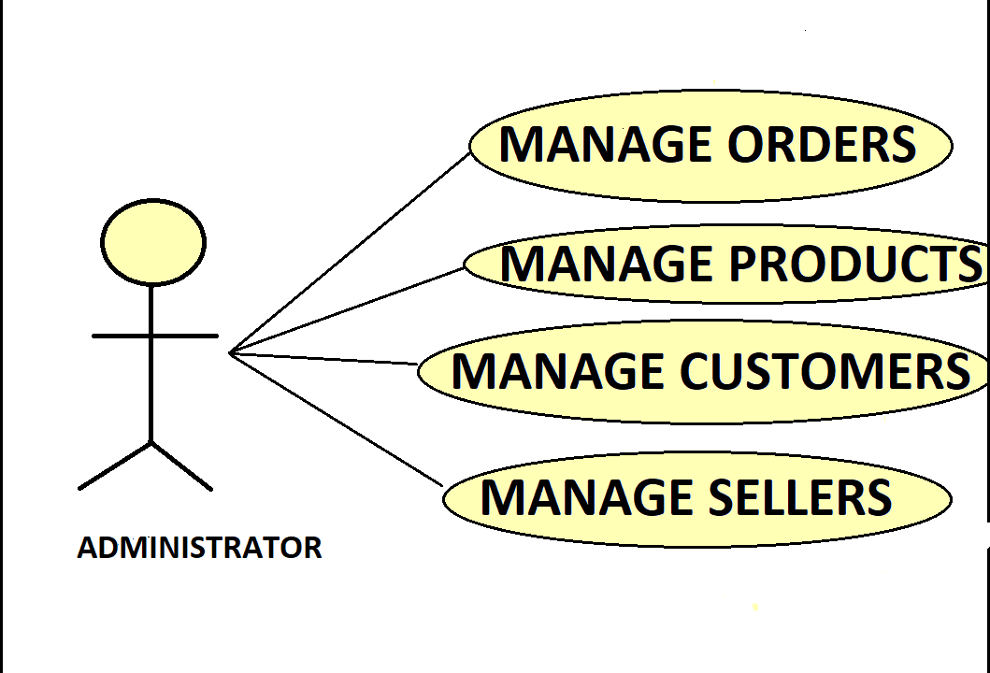

**2.1 User Account**

**The customer, who will henceforth be referred to as the ‘user,’ will be presented with different options by the e-commerce platform, depending on whether they are browsing as a guest, a registered customer, a seller, or an admin. The options available to the user will be determined by their role and whether they wish to browse products, add items to their cart or wishlist, or manage other platform features. The terms ‘registered customer,’ ‘guest,’ ‘seller,’ and ‘admin’ are described below.**

**A user who has previously registered on the platform will be provided with a unique user ID and password. This ‘personal information’ will be henceforth referred to as ‘profile.’ Such a user with a profile in the system’s database shall be called a ‘registered customer.’ A registered customer can view products, add them to their cart or wishlist, and complete purchases through the payment gateway by logging into the system.**

**A new user, on the other hand, can either: a) Register themselves on the platform by providing personal information, thereby becoming a registered customer, or b) Continue browsing as a guest.**

**In the case of ‘a,’ the new user becomes a registered customer, gaining full access to all shopping functionalities, including the ability to purchase products. In the case of ‘b,’ the new user remains a guest and can browse products, view details, and check availability but cannot add items to the cart, wishlist, or complete a purchase.**

**A registered customer can also choose to browse as a guest if they only wish to view products without making any transactions. ‘Viewing products’ always refers to browsing the available electronics categories, checking product specifications, prices, and any discount offers. The system allows the user to exit at any time during the interaction process.**

**For sellers and admins, the platform offers additional functionalities:**

* **Sellers: Can log in to view the seller dashboard, add and manage products, and handle orders.**
* **Admins: Can log in to view customer and seller details, monitor products and orders, and manage the platform's overall operations.**

**2.2 Registration and Creation of User Profile**

**The system shall require a user to register in order to carry out any transactions on the platform, except for browsing and checking product details. During the registration process, the system will prompt the user to provide the following information at a minimum: a user ID, a password, first name, last name, address, phone number, email address, and gender.**

**Upon successful registration, the system will automatically create a user profile in the database. This profile will store the user’s information and allow them to access additional features such as adding items to their cart or wishlist, and completing purchases through the payment gateway. The profile will also include a field for any promotional credits or loyalty points, which will be initialized to zero.**

**Once registered, the user can log in to the system with their user ID and password to manage their account, track orders, and update their personal information. The system ensures that all sensitive data, such as passwords and credit card numbers, are securely encrypted and stored.**



**2.3 Quick Search**

The platform provides a Quick Search facility for any user to search and view product details without logging into an account. This feature allows users to search for products across various categories, such as laptops, smartphones, speakers, and headphones, and compare their prices and specifications.

After logging in, a user (either a registered customer or a guest) will be prompted to enter specific details to refine their search. The system shall request the user to select the desired product category (e.g., laptops, smartphones) and optionally enter keywords related to the product they are searching for.

Once the product category and keywords are specified, the system will access the product database and retrieve a list of products matching the search criteria. The search results will be displayed in a tabular form, presenting the following information for each product: product name, brand, model, price, available discounts, and stock availability.

There may be several products from different brands within the same category, and all matching items will be listed based on the user's search criteria.

For each product displayed in the search results, there will be an "Add to Cart" and "Add to Wishlist" button, allowing users to quickly save the items they are interested in. If a user wishes to purchase a product, they can add it to their cart and proceed to checkout.

The system ensures that the search functionality is intuitive and provides users with accurate and relevant results, enabling them to make informed purchasing decisions.

Additionally, the Quick Search results will include a "View Details" link for each product, allowing users to see more in-depth information, such as detailed specifications, customer reviews, and related products.

**Making Purchases/Adding to Cart/Order Confirmation**

After the user has browsed the products and added items to their cart (as described in the Quick Search section), the system will now ask the user if they wish to proceed with the purchase. If the user decides to proceed:

a) If the user is browsing as a guest, they will first need to register and become a registered customer before they can complete the purchase.

b) If the user is already a registered customer and has logged in, they can proceed with the purchase directly. However, if the user was previously browsing as a guest, they will need to log in before proceeding.

Once the system verifies that the user is logged in according to the established process, it will prompt the user to review their cart. The system will display all the selected items, including their quantities, prices, and any applicable discounts. The user can make adjustments to their cart, such as updating quantities or removing items, before finalizing the purchase.

The system will then calculate the total amount for the order, including taxes, shipping costs (if applicable), and any discounts. The user will be informed of the final amount to be charged.

Next, the system will prompt the user to enter their payment details, such as credit card or debit card information. The system ensures that the payment information is securely processed and encrypted. Once the payment information is entered, the system will charge the total amount to the user's provided payment method.

If the purchase is successful, the system will proceed to update the order database. The inventory for the purchased items will be decremented by the quantities ordered. The system will then generate an order confirmation, which will include the order details, shipping information, and estimated delivery date.

The system will also send a confirmation email to the user, containing a summary of the purchase, order number, and tracking information (if applicable).

Finally, the user will be redirected to an order confirmation page, where they can view their order summary and receive further instructions on how to track their shipment or manage their order.

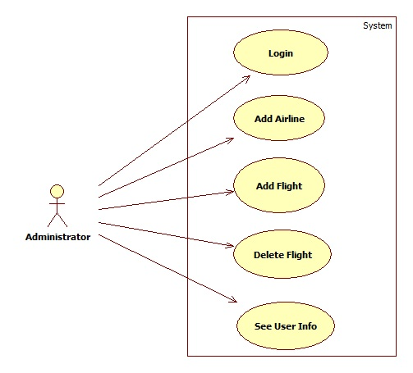

Admin should be able to login ,add product information , view customer information,

View seller information.

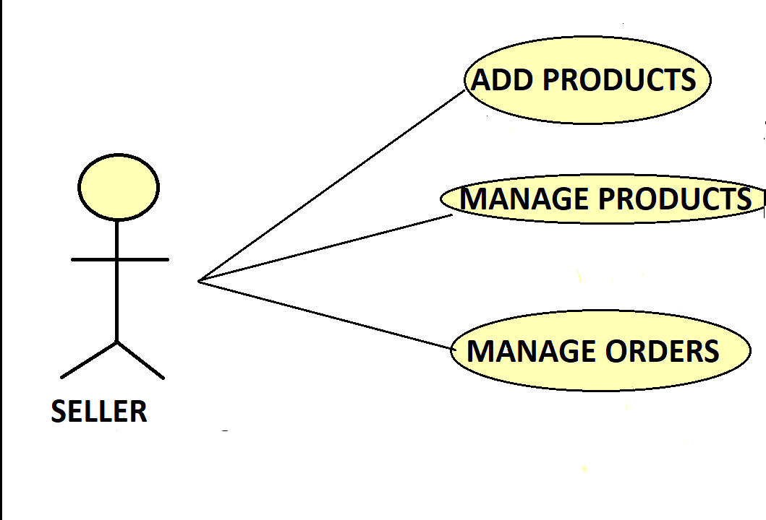

* 1. **NON FUNCTIONAL REQUIREMENTS**

**2.2.1 Interface**

Go to Appendix B for user interfaces

**2.2.2 Performance**

* **Number of Concurrent Users:**

ARS shall be able to handle at least 1000 transactions/inquiries per

second

* **Booking of Tickets:**

The system is susceptible to any temporary server failure since it uses the strong feature of Struts 2 and Hibernate. Hence the examination will be continued even if the sever gets disconnected in between the examination.

**2.2.3 Constraint**

ARS shall be able to handle at least 1000 transactions/inquiries persecond

**2.2.4 Other Requirements:**

* **Hardware Interfaces**

The SPMS is expected to function on Intel PIII 900 MHz Processor equivalent or above, 128 MB RAM, 20 GB HDD.

* **Software Interfaces**

The SPMS shall work on MS Windows operating systems family (MS Windows 98, MS Windows NT Workstation, MS Windows 2000, MS Windows XP). It configures to work with Oracle database. This System works on Apache Tomcat server. It uses browser IE 5.0 & above. It uses IIS 5.0 server.

**3. DESIGN**

**3.1 Database Design**

The following table structures depict the database design.

# Table1: User_Info

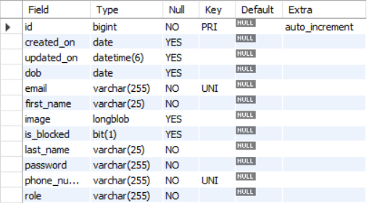

Seller

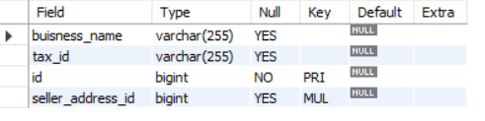

Customer

### 

**Address**

### 

products

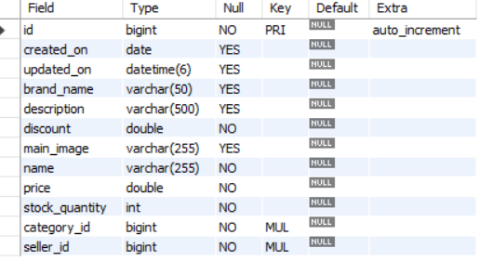

carts

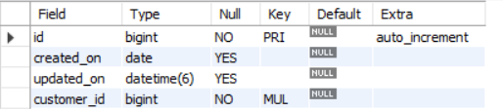

Wishlist

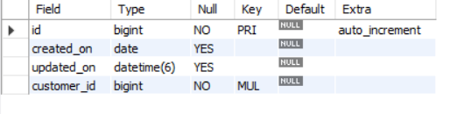

**4. CODING STANDARDS IMPLEMENTED**

### Naming and Capitalization

Below summarizes the naming recommendations for identifiers in Pascal casing is used mainly (i.e. capitalize first letter of each word) with camel casing (capitalize each word except for the first one) being used in certain circumstances.

|  |  |  |  |
| --- | --- | --- | --- |
| **Identifier** | **Case** | **Examples** | **Additional Notes** |
| Class | Pascal | Person, BankVault, SMSMessage, Dept | Class names should be based on "objects" or "real things" and should generally be **nouns**. No ‘_’ signs allowed. Do not use type prefixes like ‘C’ for class. |
| Method | Camel | getDetails, updateStore | Methods should use **verbs** or verb phrases. |
| Parameter | Camel | personName, bankCode | Use descriptive parameter names. Parameter names should be descriptive enough that the name of the parameter and its type can be used to determine its meaning in most scenarios. |
| Interface | Pascal with "I" prefix | Disposable | Do not use the ‘_’ sign |
| Property | Pascal | ForeColor, BackColor | Use a noun or noun phrase to name properties. |
| Associated private member variable | _camelCase | _foreColor, _backColor | Use underscore camel casing for the private member variables |
| Exception Class | Pascal with "Exception" suffix | WebException, |  |

### Comments

* Comment each type, each non-public type member, and each region declaration.
* Use end-line comments only on variable declaration lines. End-line comments are comments that follow code on a single line.
* Separate comments from comment delimiters (apostrophe) or // with one space.
* Begin the comment text with an uppercase letter.
* End the comment with a period.
* Explain the code; do not repeat it.

**5. TEST REPORT**

**Another group called Linux did the testing and the report of the testing is given hereunder.**

**GENERAL TESTING:**

|  |  |  |  |  |
| --- | --- | --- | --- | --- |
| **SR-NO** | **TEST CASE** | **EXPECTED RESULT** | **ACTUAL RESULT** | **ERROR MESSAGE** |
| 1 | Register Page | Redirected to Next page | OK | Nothing |
| 2 | Login Page | Pop-up will come | Ok | Please enter username and password again . |
| 3 | Reset login | Only users password will be reseted | Ok | Nothing |
| 4 | Quick search produc | Gives all product details | Ok | Nothing |
| 5 | Product buy | All the fields should be filled for submission | Ok | Nothing |
| 6 | Checking login or not | User is logged in or not | Ok | Nothing |
| 7 | Add person address for buyin | Add informations accordingly | Ok | Nothing |
| 8 | Goto orders page | Set added information about person | Ok | Nothing |
| 9 | Add information in address table | Save this all data into address table | Ok | Nothing |
| 10 | Transaction | On back it should be reverted to previous page | Ok | Nothing |
| 12 | Logout | It will logout from user profile. | Ok | Nothing |
|  | **STATIC TESTING** |  |  |  |
| **SR-NO** | **Deviation** | **Program** |  |  |
| 1 | Commenting not followed | All Web Application |  |  |
|  |  |  |  |  |

**6. PROJECT MANAGEMENT RELATED STATISTICS**

|  |  |  |  |
| --- | --- | --- | --- |
| **DATE** | **WORK PERFORMED** | ****SLC Phase**** | **Additional Notes** |
| july 15,2024 | Project Allotment and User Requirements Gathering | Feasibility Study | Our team met the client Mr. Nitinkudale (CEO, SIIT Pune) to know his requirements. |
| july 17,2024 | Initial SRS Document Validation  And Team Structure Decided | Requirement Analysis  (Elicitation) | The initial SRS was presented to the client to understand his requirements better |
| July 18,2024 | Designing the use-cases, Class Diagram, Collaboration Diagram, E-R Diagram and User Interfaces | Requirement Analysis &  Design Phase | Database Design completed |
| July 19,2024 | Business Logic Component design Started | Design Phase | ---------------------- |
| July 20,2024 | Coding Phase Started | Coding Phase | 70% of Class Library implemented. |
| July 21,2024 | Implementation of Web Application and Window Application Started | Coding Phase | Class Library Development going on. |
| July 22, 2024 | Off | Off | Off |
| july 28, 2024 | Implementation of Web Application and Window Application Continued | Coding Phase and Unit Testing | Class Library Modified as per the need. |
| JAN 29, 2024 | Implementation of Web Application and Window Application Continued | Coding Phase and Unit Testing | -- |
| Aug 1, 2024 | After Ensuring Proper Functioning the Required Validations were Implemented | Coding Phase and Unit Testing | Module Integration was done by the Project Manager |
| Aug 6, 2024 | The Project was Tested by the respective Team Leaders and the Project Manager | Testing Phase (Module Testing) | -- |
| Aug 11, 2024 | The Project was Submitted to Other Project Leader of Other Project Group For Testing | Testing Phase (Acceptance Testing) | The Project of Other Team was Taken up by the Team for Testing |
| Aug 15, 2024 | The Errors Found were Removed | Debugging | The Project was complete for submission |
| Aug 16, 2024 | Final Submission of Project |  |  |

**Class Diagram**

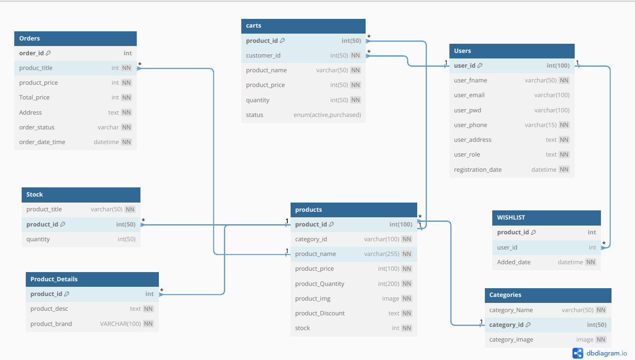

Appendix B

Homepage: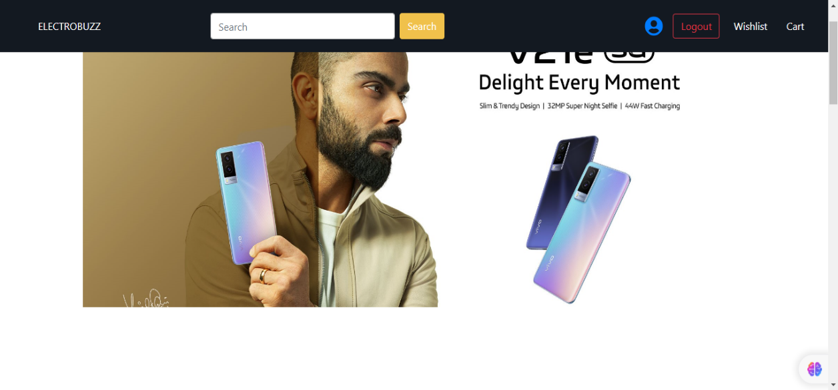

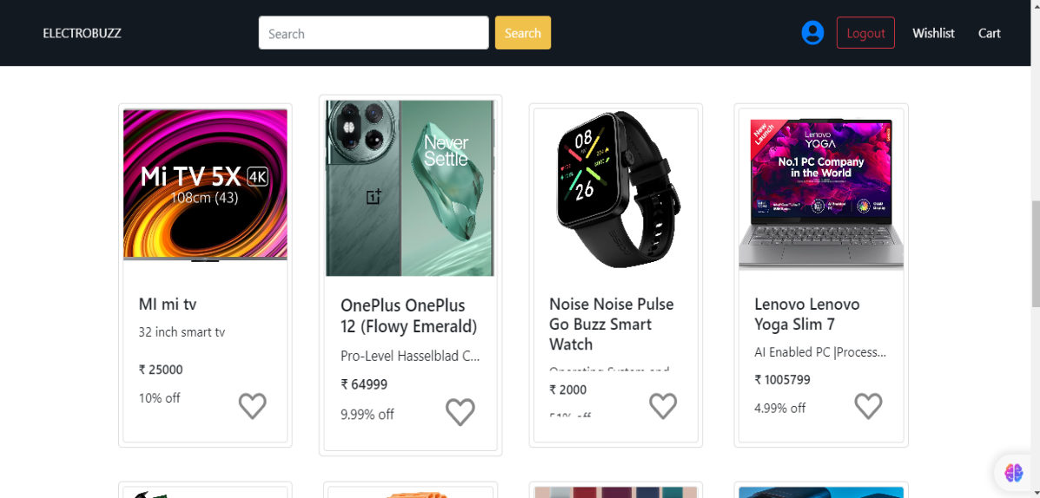

LoginPopup: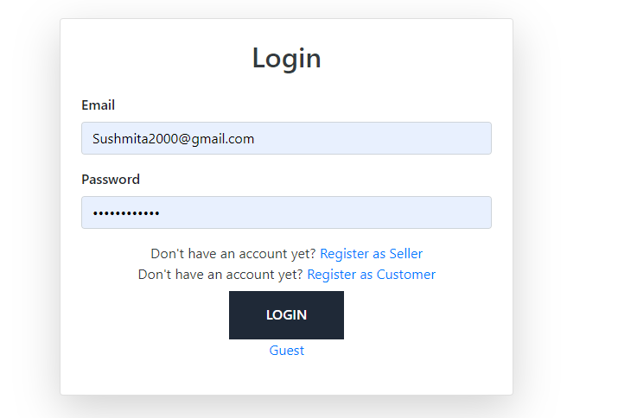

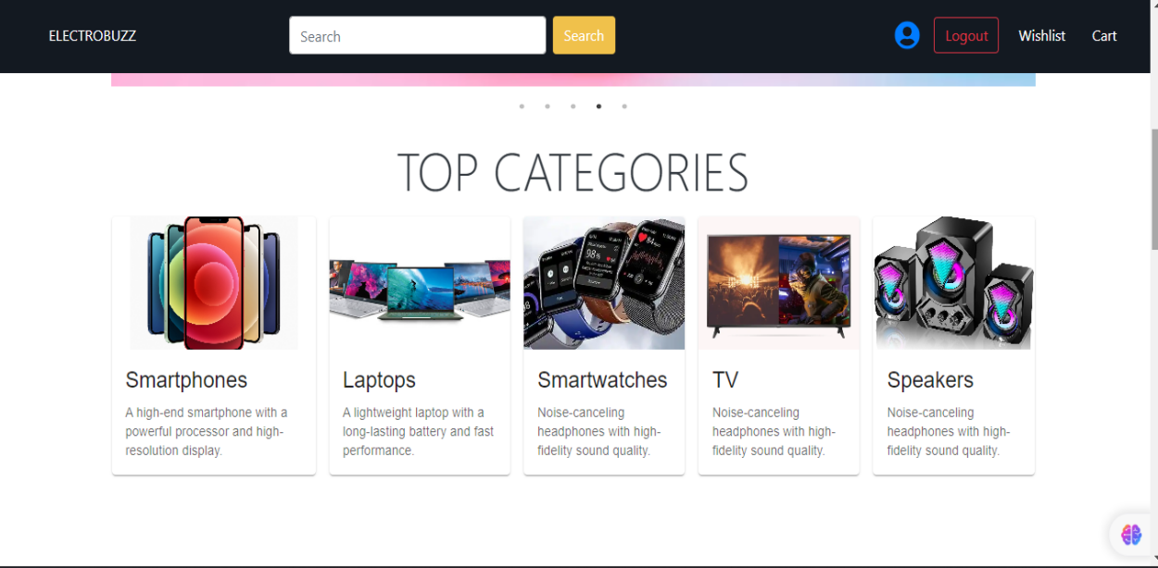

Search results

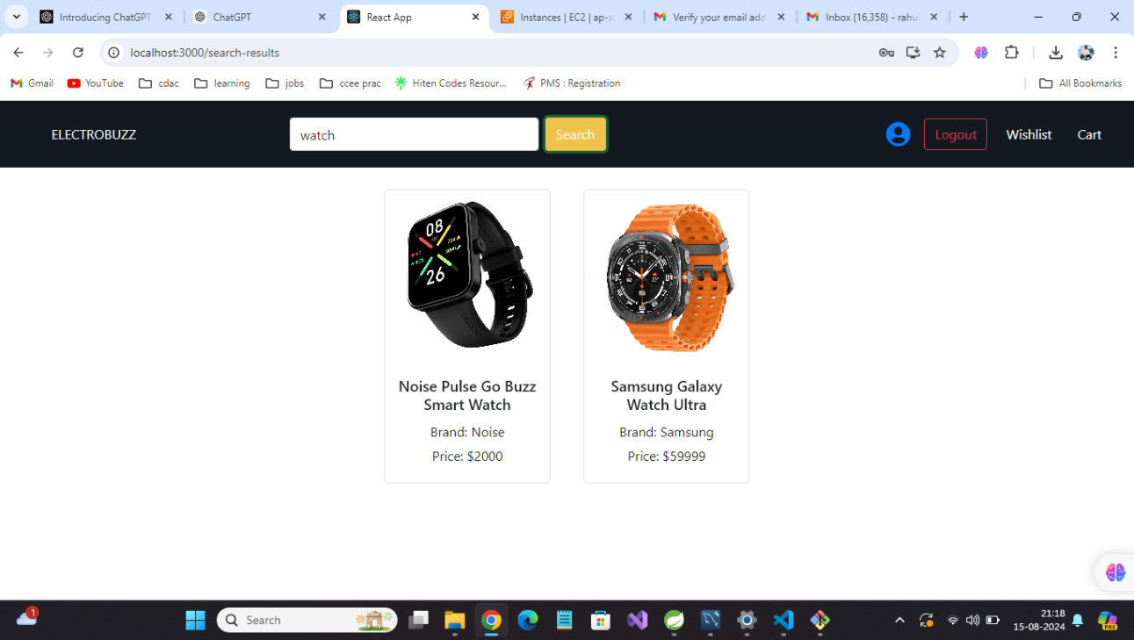

UserProfileDetails: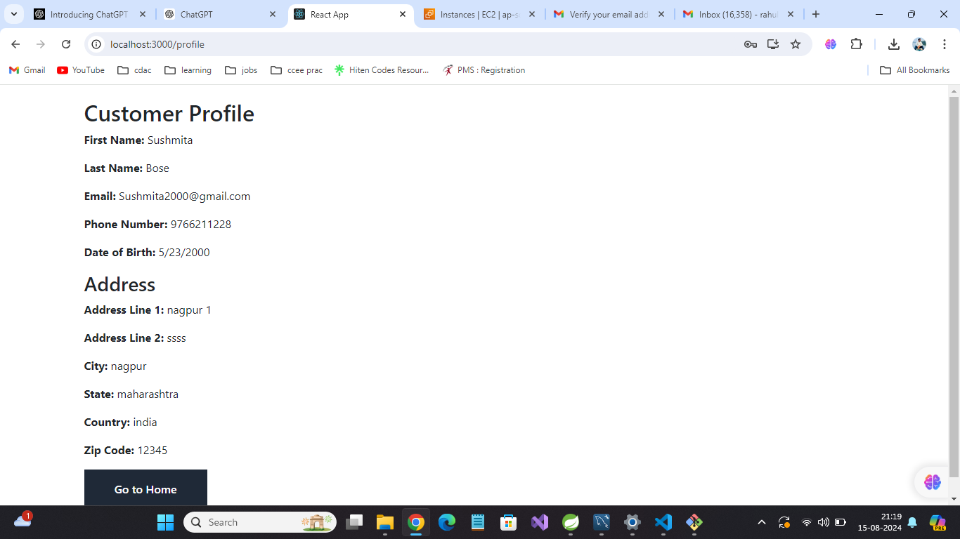

**Wishlist**

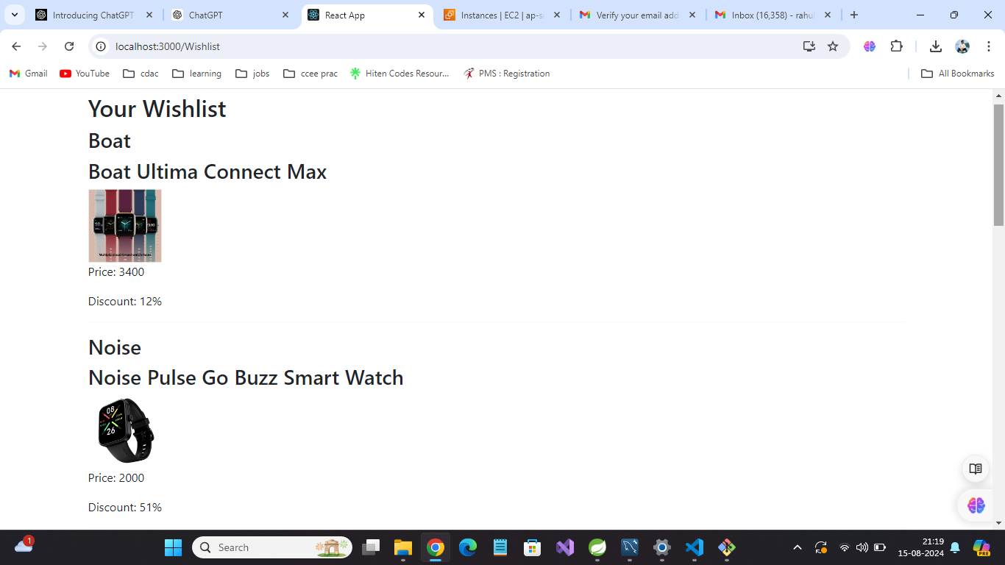

Cart

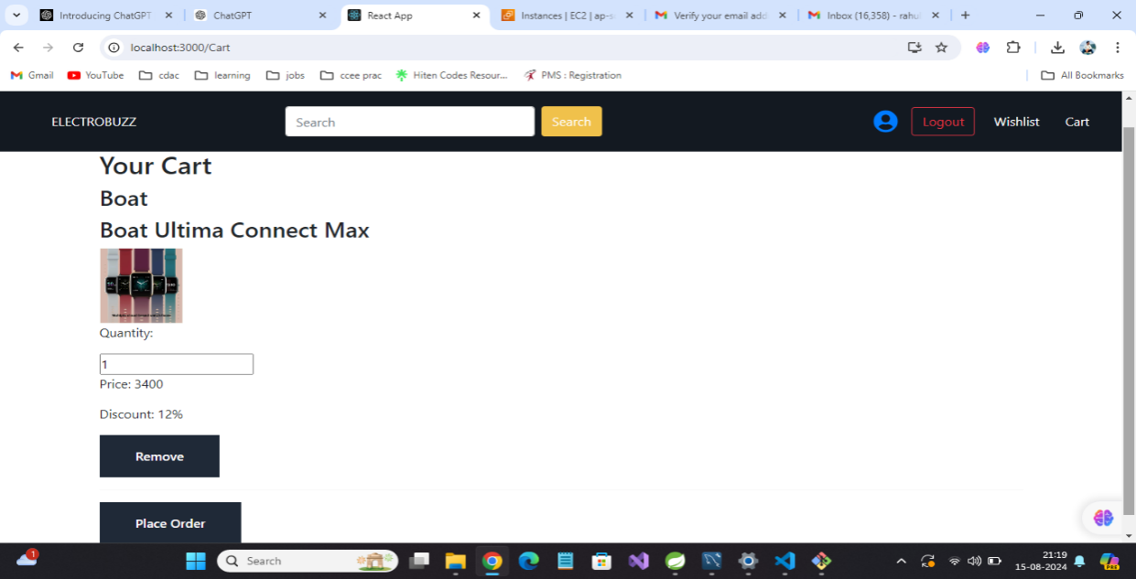

Orders

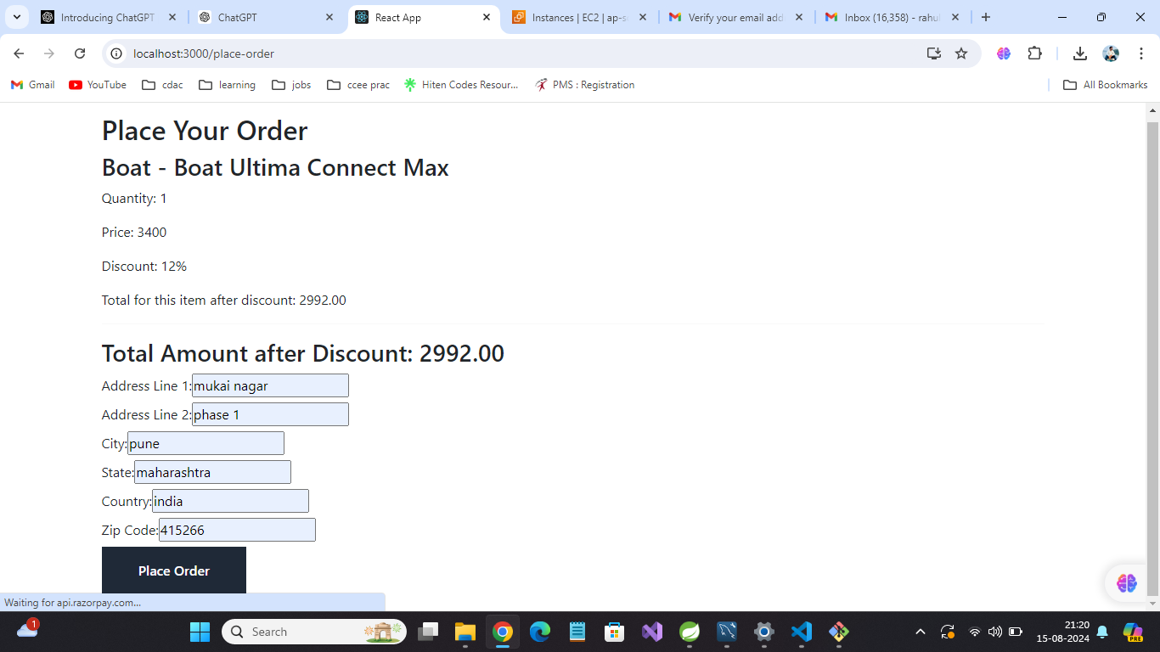

Payment

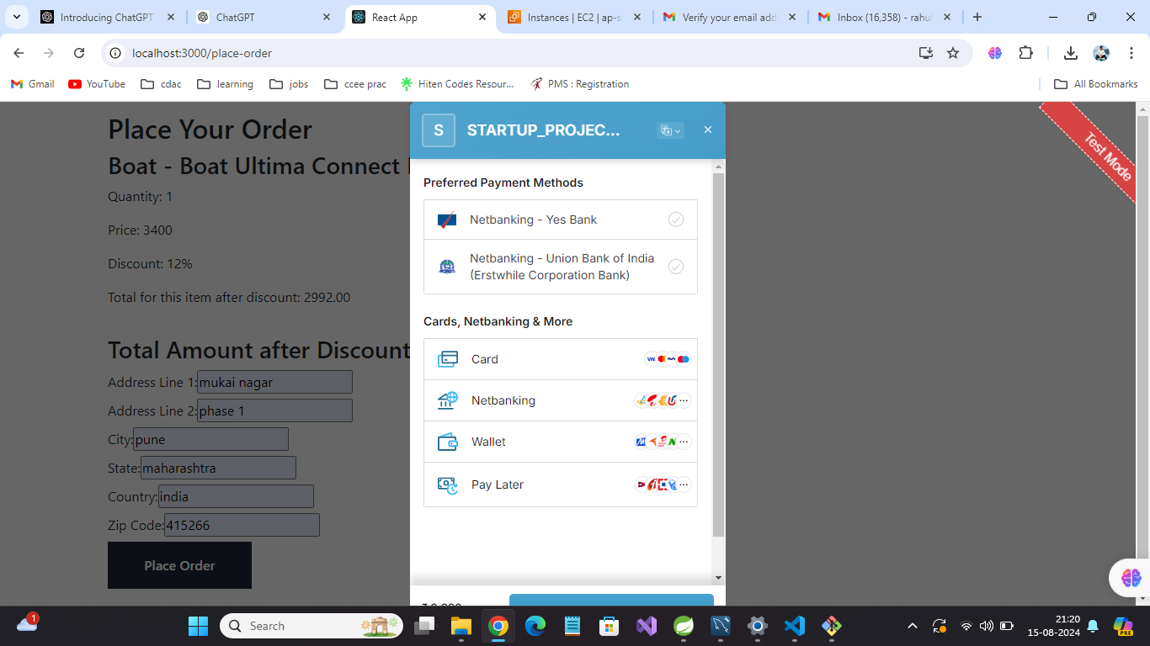

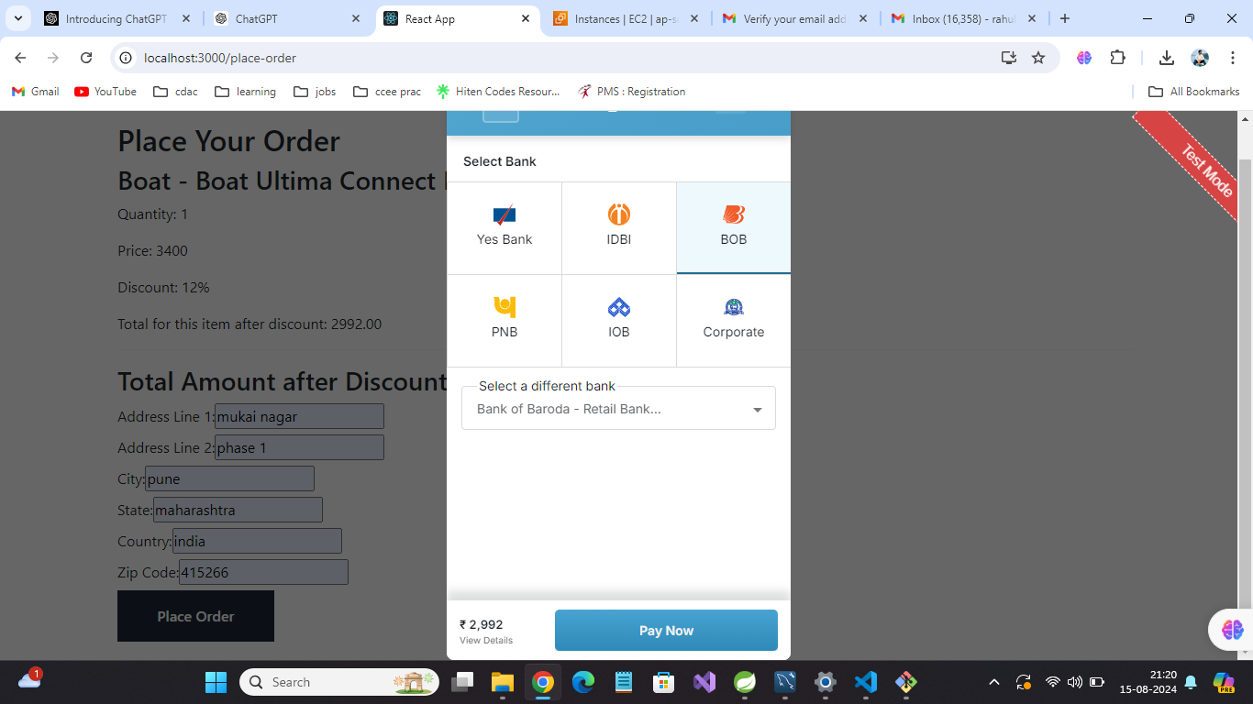

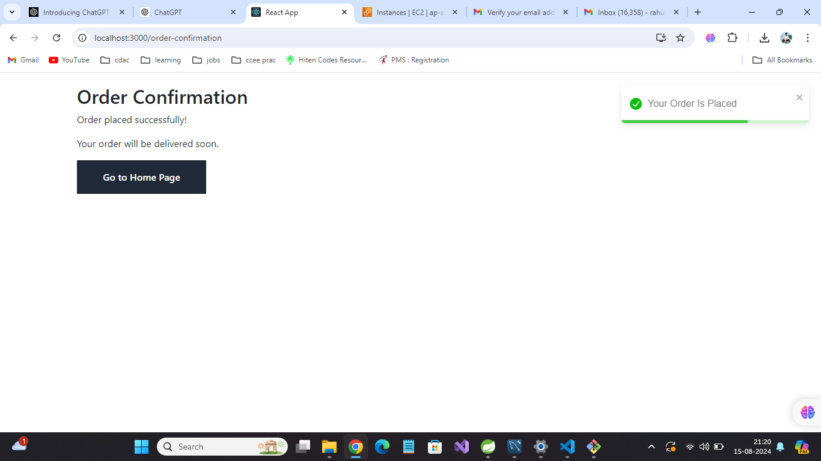

**7.REFERENCES:**

<http://www.google.com>

http://www.webdevelopersjournal.com/

http://www.w3.org

http://www.wikipedia.org